
PROJECT TITLE: PDF TO WORD CONVERTER

Name | HUNAIN ALI, REHAN KAMALI
Roll no | 2301010-083, 23010101-032
Subject | WEB ENGINEERING
Section | BSSE 6TH GREY
Submitted To: | SIR MUSEB KHALID

Introduction:
The PDF to Word Converter is a client-side web application developed using Vue 3 and Vite. The main purpose of this project is to provide a simple and user-friendly interface for managing the PDF to Word conversion process. This deliverable focuses on implementing the frontend architecture of the application by utilizing modern Vue.js concepts such as Single Page Application (SPA) routing, reusable components, and inter-component communication.
The application is designed to offer smooth navigation between different pages without reloading the browser. It also demonstrates a modular structure that improves code readability, maintainability, and scalability. This project serves as the first phase of the semester project, where only the client-side functionality is implemented, while backend integration will be added in future phases.
About the Project
The PDF to Word Converter is designed to simplify the document conversion workflow by providing an intuitive and organized user interface. The application consists of multiple pages, including Home, Converter, About, and Help, which are connected using Vue Router to create a seamless Single Page Application experience.
The project follows a modular architecture where the user interface is divided into reusable Vue components such as the header, sidebar, footer, file uploader, file list, conversion progress, and conversion result components. Data is passed between parent and child components using Props, while user actions are communicated back to parent components using Custom Events ($emit). This architecture promotes code reusability, better organization, and easier maintenance.

Architecture Tree
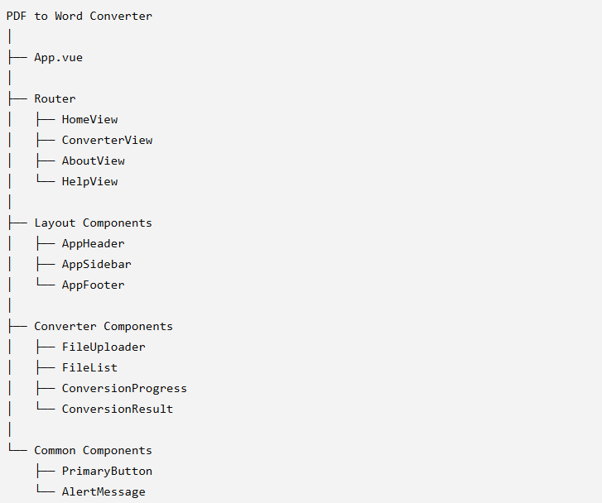

Code Snippets:
Router Code Snippet
import { createRouter, createWebHistory } from 'vue-router'
import HomeView from '@/views/HomeView.vue'

const router = createRouter({
history: createWebHistory(import.meta.env.BASE_URL),
routes: [
{
path: '/',
name: 'home',
component: HomeView
},
{
path: '/converter',
name: 'converter',
component: () => import('@/views/ConverterView.vue')
},
{
path: '/about',
name: 'about',
component: () => import('@/views/AboutView.vue')
},
{
path: '/help',
name: 'help',
component: () => import('@/views/HelpView.vue')
}
],
scrollBehavior() {
return { top: 0 }
}
})

export default router

Output:

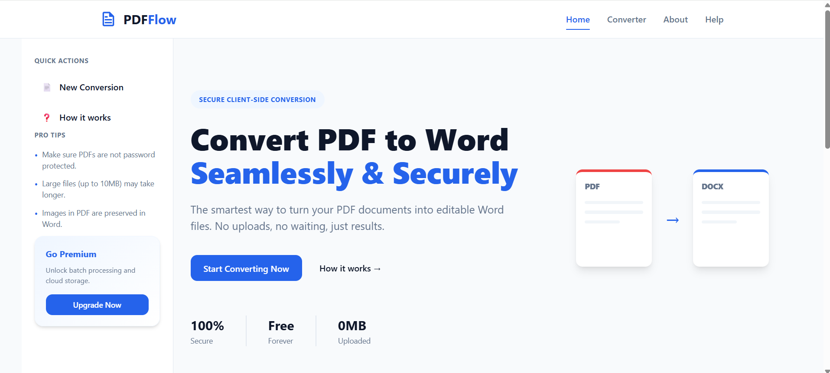

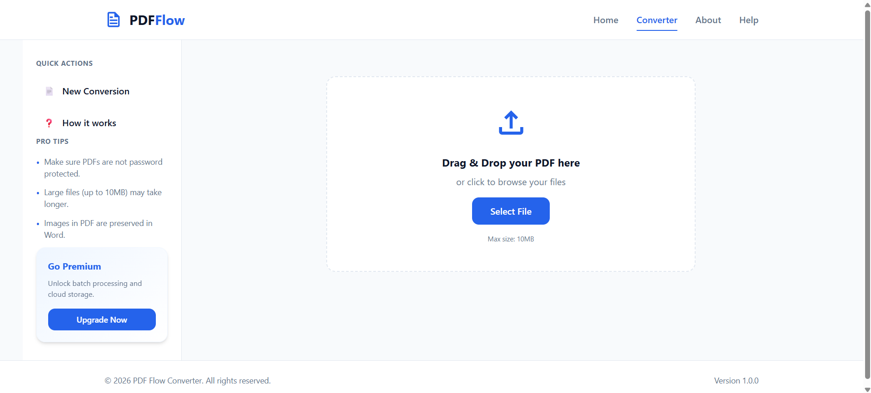

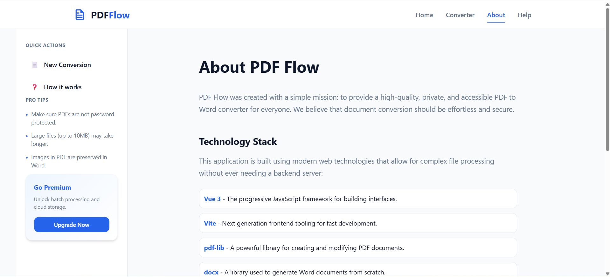

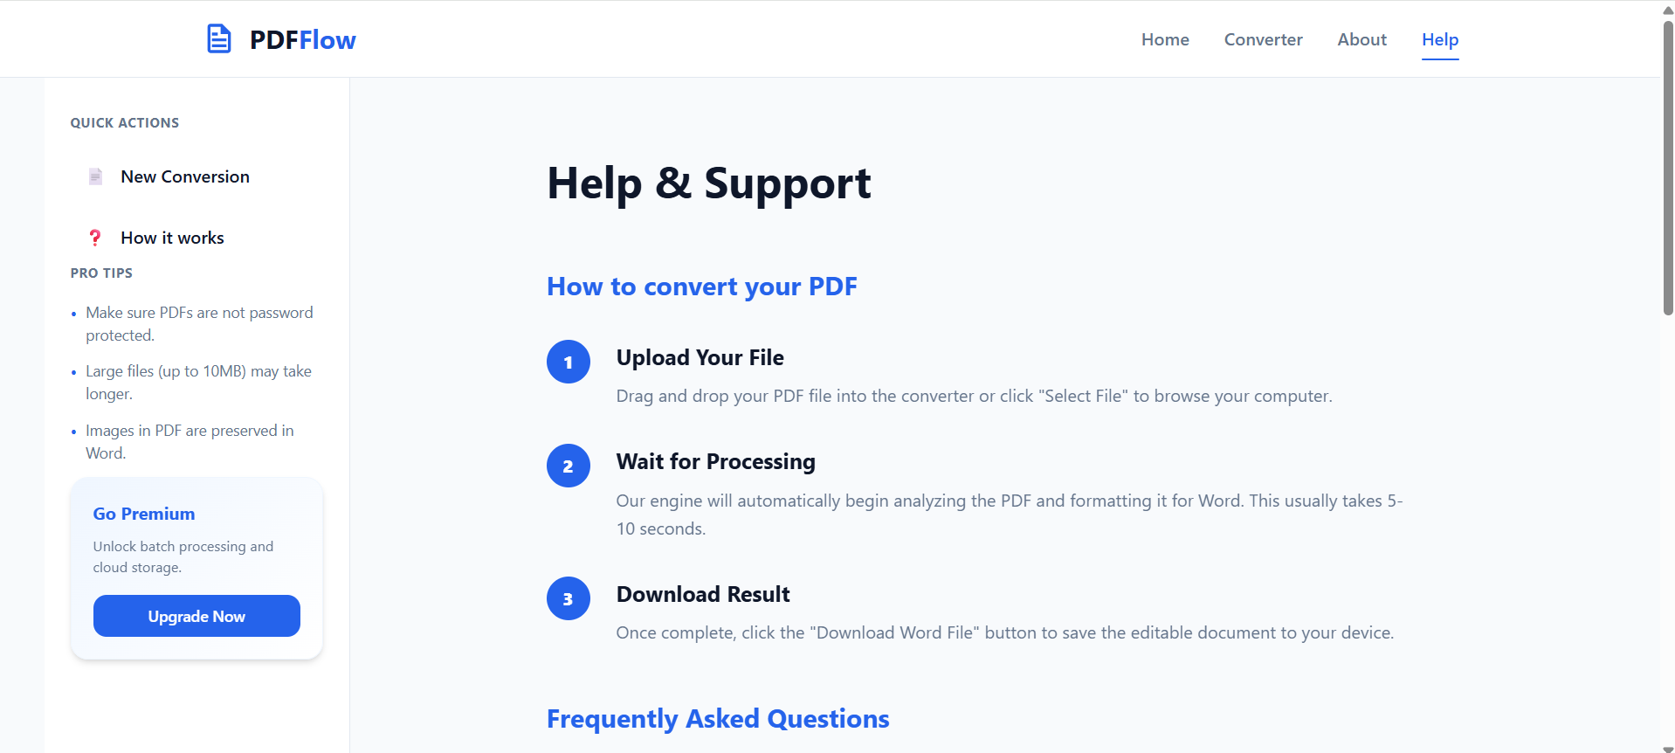

Conclusion
The PDF to Word Converter project successfully demonstrates the implementation of a modern client-side web application using Vue 3 and Vite. The project effectively utilizes SPA routing, modular component architecture, and Props and Custom Events to build a structured and maintainable application.
Through this project, important frontend development concepts such as component reusability, dynamic navigation, and parent-child communication have been implemented successfully. The current deliverable establishes a strong client-side foundation, making it ready for future backend integration with technologies such as Express.js and MongoDB. Overall, the project fulfills the required objectives of the first semester project deliverable and demonstrates the practical application of Vue.js frontend development principles.

